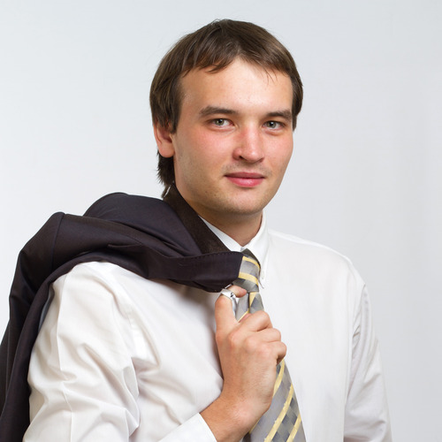 |  | Oseledko Andriy Mychailovich  Male, 24 years old, born in 15 of October 1989  +38 (067) 5027649  oseledko.a@gmail.com — preferred contact  icq: 397494200  skype: simafish  Address: 12/62 Salutna st., app. 64, Kiev, Ukraine  Reside in: Kiev, st. Nivki  Citizenship: Ukraine  Ready for business trips
Experience —3 years 2 months
June 2013 — till now  6 months |  | GlobalLogic Ukraine  Kiev, www.globallogic.com.ua — Information technology  Oracle Developer  - working with media enterprise solution (IBMS) on Pilat Media project  - developing new functionality and making deploying plans  - improving system logic and code refactoring  - system bug fixing and investigating issues  Technologies in use: PL/SQL, SQL, C#.  Tools: PL/SQL Developer, MS Visual Studio 2010, Tortoise SVN.
March 2012 — June 2013  1 year 4 months |  | Terrasoft  Ukraine, www.terrasoft.ua — Information technology  Developer of business solutions  - realization of client business processes in CRM system  - new functional implementation in basic versions of Terrasoft CRM  - packages, stored procedures and functions of Oracle database development  - Terrasoft CRM solutions integration with other systems  - writing and optimization of difficult SQL queries  - code debugging and testing, problems solving  - creating reports in FastReport, MS Excel, HTML (with Oracle XMLTYPE)  Used technologies: JScript, PL/SQL, SQL, C#, HTML, CSS, JavaScript, XML, XSLT, FastReport.  Tools: TOAD for Oracle, MS Visual Studio 2012, MS SQL Server Management Studio, Tortoise SVN.
December 2011 — March 2012  4 months |  | Raiffeisen Bank Aval  Kiev, www.aval.ua — Financial industry  Lead specialist  - maintenance and support of Card Suite Issuing (TransMaster)  - patches and updates testing and installation  - monthly client billing realization  - bank software documentation writing  - analysis and solution of system incidents  Used technologies: PL/SQL, SQL, PHP. Tools: TOAD for Oracle.
October 2010 — December 2011  1 year 3 months |  | Raiffeisen Bank Aval  Kiev, www.aval.ua — Financial industry  Specialist of 1st category  - support of Card Suite Issuing (TransMaster)  - installation and support of programs-satellites  - creation of system work reporting  Used technologies: SQL, PHP.  Tools: TOAD for Oracle.
Higher education
2012 |  | Vadym Hetman Kyiv National Economic University  Decision Making Systems in Economy, Master's degree in Computer Science
Additional education
2009 |  | Web-design  "Perspectiva - XXI-st century", Certificate of course completion
2009 |  | Web-programming  "Perspectiva - XXI-st century", Certificate of course completion
Skills
Languages |  | Ukrainian — native— enough for interview— fluent
Skills |  | - Windows (98 – 8), MS Office, Visual Studio  - HP ServiceDesk, Lotus Notes, Lotus SameTime, Terrasoft CRM  - Oracle 11g, SQL*Plus, TOAD for Oracle, SQL, PL/SQL  - MS SQL Server Management Studio, T-SQL  - HTML, CSS, PHP, MySQL, XML/XSLT, JScript/JavaScript  - Pascal, Delphi, C++, C#, Turtoise SVN  - Adobe Photoshop, Sony Sound Forge Pro  - local and Wi-Fi networks building  - complex diagnostics and PC repair
Additional information
Recommendations |  | GlobalLogic Ukraine  Ielizaveta Voron (Head of the development team). +380676587454  Terrasoft  Igor Maltsev (Head of the development team). +380504122406  Raiffeisen Bank Aval  Dmitriy Gurov (Head of Card Systems & Terminal Network Support Division). +380504633744  Centr-invest Bank  Maxim Totskiy (Project manager of IT department). +79281318582
Portfolio |  | http://www.oldfishman.ho.ua/portfolio/Portfolio.rar

